Installation Instructions for Novabraid SSL 2.0 Breakaway Link

Novatec Braids, in conjunction with the Massachusetts South Shore Lobsterman’s Assn, developed the SSL 2.0 breakaway link for use in creating a 1700lb break strength vertical buoy and hauling line for lobster pots and lobster pot trawls.
The Links are available in 3/8” and ½” diameters and work on 3 strand lines of equivalent diameters. The Links work on the premise of braid constriction and are hollow in structure to allow the three strand pot warp to be inserted in either end of the link, creating a weaker segment than that of the actual pot rope.
To install the product:
- Cut the 3-strand rope at approximately 40’ intervals using a hot knife or taping and cutting the area where the cut will occur.
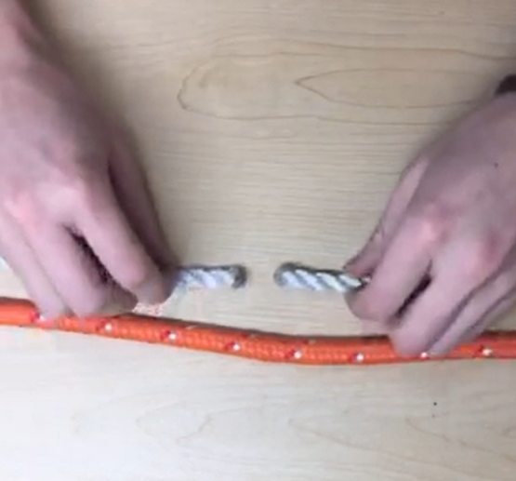
- On each end of the link, using a scissors or knife cut a slit approximately 1 ½” long.
- Using a marker, fold the link in half and make a mark at the mid-point of the link.
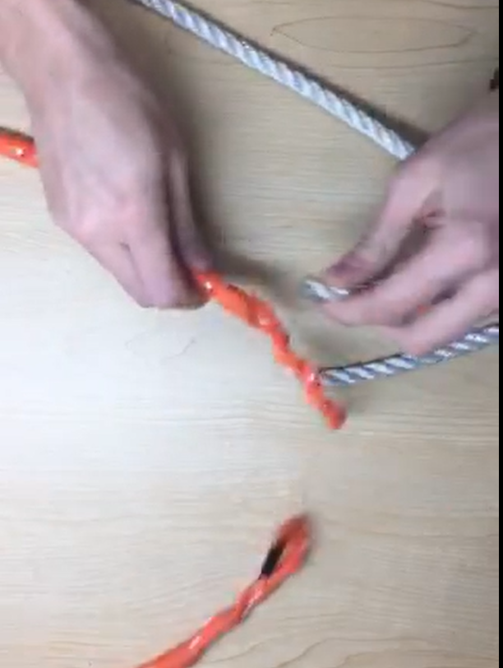
- Insert one end of the three-strand rope into the end of the link, and slowly milk the end of the 3 strand rope further into the link until 3 feet of rope has been worked into the link or right to the center mark made in the above step.
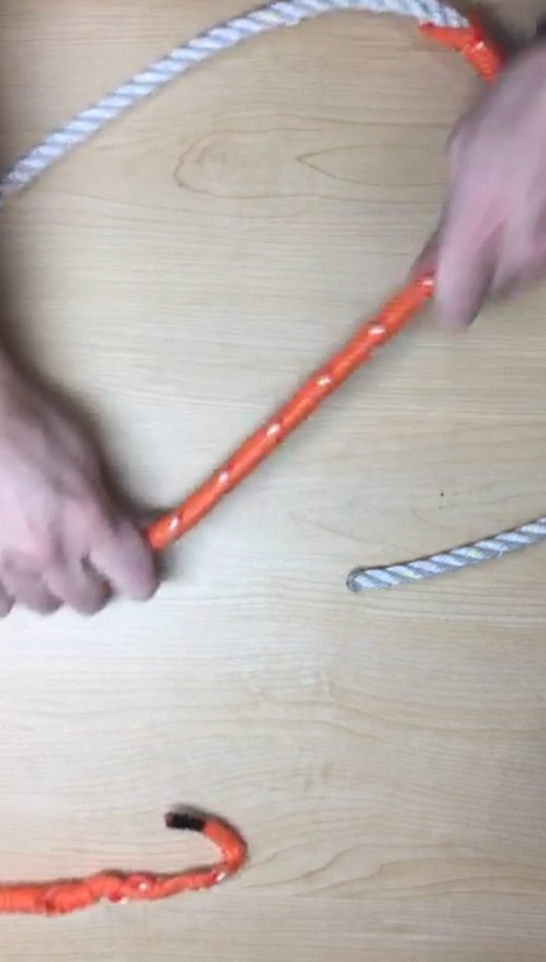
- Now repeat the last step, inserting the other cut end of the three-strand into the opposite end of the link. Continue to work the three-strand into the link until it meets the other length of 3 strand inside the link.
- To secure the 3- strand rope into the link and to make a smooth transition from the link to the pot rope, tuck the cut end of the link into a few strands of the three-strand rope to make sure none of the link is loose.
